Teaching Staff
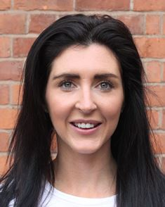 | 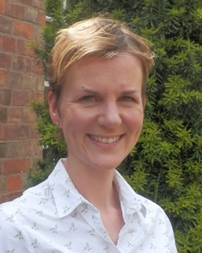 | 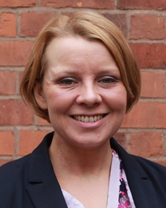
Kat Berns KAB | Mariana Hunton MFH | Julia Landon JCL
Teacher of PE and Games | Teacher of Spanish and French | Teacher of History

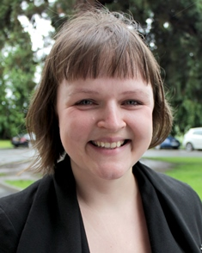 |  | 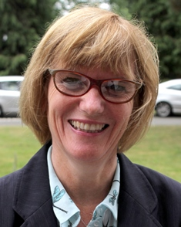
Kate Limb KHL | John McNamara JFM | Marion Mitchell MKM
Teacher of History | Teacher of Economics | Teacher of Business and Economics

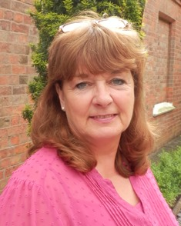 | 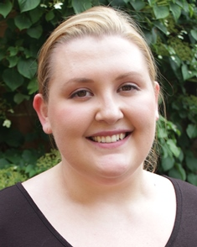 | 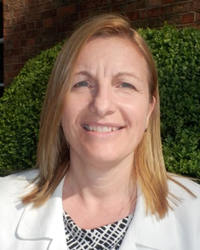
Anne O’Hanlon AOH | Alex Philpot ARP | Jan Ryalls JMR
Teacher of Food Technology | Teacher of Religious Studies | Teacher of Computer Science

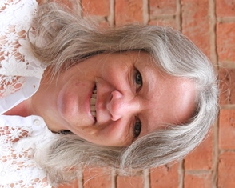 | 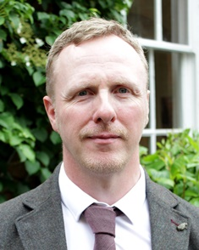
Sarah Sephton SLS | Steve White SAW
Head of Physics | Teacher of Chemistry and Science

Teaching Assistants

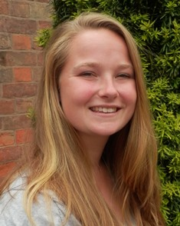 | 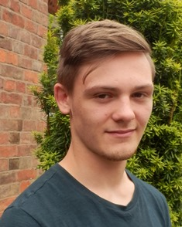
Emma Nobes ELN | Taylor Vaughan TBV
Teaching Assistant | Teaching Assistant

